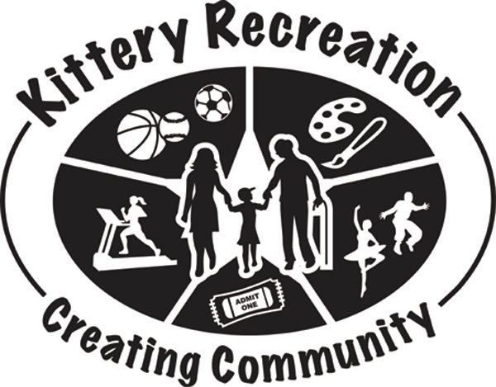Kittery Recreation Center Activities
Waiver, Release and Indemnity Agreement
(To be filled out and updated on an annual basis by/for the participant)

Participant Name: ____________________________________Date of Birth: ___________________

Street Address: _____________________________________Age: _______ Male ___ Female ___

City, State, ZIP: ______________________________________Home Phone:____________________

Parent/Guardian Name 1: _____________________________Daytime Phone: __________________

Parent/Guardian Name 2: _____________________________Daytime Phone:__________________

Email Address and Contact Person:______________________________________________________

WAIVER, INDEMNITY, AND RELEASE OF LIABILITY

Identification of Risk:

The undersigned participant (or the parent or guardian of the above-named participant who is a minor), understands that inherent and other risks involved in sporting, exercise, or other types of recreational sponsored activities could result in injuries or illness to the participant. I understand that these injuries might result not only from my actions but from the actions and inactions of others. Given this awareness, I, the undersigned participant (or the parent or guardian of the above-named participant who is a minor), nevertheless give my consent and permission for me or the minor participant to participate in all Kittery Recreation Center activities.
_________________________ [initial]

Waiver, Release and Indemnity:

** PLEASE READ CAREFULLY BEFORE SIGNING **

I understand and hereby agree to assume all of the risk which may be encountered with the participant’s participation in the Kittery Recreation Center sponsored activities. To the fullest extent allowed by law, I hereby release and hold harmless the Kittery Recreation Center and the Town of Kittery, its officials, agents and employees from any and all responsibility and legal liability for any property or personal injury damages to the participant resulting from any claim arising from my (or the minor’s) participation in a Kittery Recreation Center activity or sponsored activity and I will indemnify, hold harmless, and defend them if any and all liability, actions, causes of actions, claims, expenses, and damages on account of any property or personal damages or injuries sustained by the participant which may arise out of and in connection with any activity or participation by the participant or minor in Kittery Recreation Center activities.

_______________________ [initial]

(continued on other side)

Page 1 of 2

I expressly agree that this release, waiver & indemnity agreement is intended to be broad and inclusive in its terms and is to be interpreted as permitted by Maine law. If any portion hereof is held to be invalid or unenforceable, it is agreed that the remainder shall continue in full legal force and effect. this release contains the entire agreement between the parties hereto and the terms of this release are contractual and not a mere recital. I intend for this waiver, release and indemnity agreement be binding upon my relatives, personal representatives, heirs and assigns.

This waiver does not release acts of gross negligence nor willful and wanton misconduct of any party.

I further state that I, the undersigned, have fully read the foregoing release, waiver and indemnity agreement, as well as the identification of risk, and know the contents thereof and sign this document as my own free act and deed.

________________________________________ __________________________________
Participant signature Print Name
Date: __________________

For participants under age 18:
I consent to the above person’s participation in the Kittery Recreation Center activities. I acknowledge for myself and/or as the parent or guardian with legal responsibility for the minor participant, I verify that I have the authority to enter into this Agreement on behalf of the minor participant.

________________________________________ _______________________________________
Parent/Guardian signature if participant is a minor Print Name
Date: ___________________

Release to Use Photos

I, the above-named participant, or parent or guardian for the above-named participant, hereby
GRANT _____ DENY _____ [initials: ____________]
the authority to use any photos taken of the participant in the course of any Kittery Recreation Center activity for use in any informational or promotional brochures or other publications of the Kittery Recreation Center.

___________________________________ ______________________________________
Participant signature Print Name
Date: ________________

___________________________________ ___________________________________
Parent/Guardian signature if participant is a minor Print Name
Date: __________________________

